# MetaSynth & Composer Desktop Pro: tools behind Aphex Twin’s **Windowlicker EP**

## Background

The 1999 *Windowlicker EP* is an iconic release by Richard D. James (Aphex Twin). The EP’s B‑side contains a track with the unpronounceable title “∆Mᵢ⁻¹=−α ∑ Dᵢ[η][∑ Fjᵢ[η−1]+Fextᵢ[η⁻¹]]”, often shortened to **Formula**. In 2001 a listener noticed that when the final minutes of this track are examined with a spectrogram there is a **grinning face hidden in the spectrum**. Mixmag later confirmed that James embedded this image using the **MetaSynth** software[[1]](https://mixmag.asia/feature/spectrogram-art-music-aphex-twin#:~:text=tweaking%2C%20particular%20tracks%20reveal%20images,placed%20there%20by%20the%20artist). The discovery highlighted how image‑to‑sound synthesis could be used as both a musical tool and an Easter egg. The A‑side *Windowlicker* also ends with an eerie swirl; when the last eight seconds are analysed with a spectrogram the high‑pitched cry becomes a **spiral‑like image**[[2]](https://mixmag.asia/feature/spectrogram-art-music-aphex-twin#:~:text=On%20the%20same%20EP%20but,like%20swirl%20as%20Jarmo%20found). These tricks triggered curiosity about the software Aphex Twin used.

## MetaSynth

MetaSynth, created by U&I Software, is a **multi‑room sound‑design laboratory**. It runs as a stand‑alone application on macOS and has been used by composers such as Hans Zimmer, film sound designers and artists like Aphex Twin. The KVR product page summarises its architecture: each room presents “a unique take on music and sound sculpting”[[3]](https://www.kvraudio.com/product/metasynth-by-u-and-i-software#:~:text=and%20fun%20to%20use,discover%20new%20sounds%20and%20textures). MetaSynth features **six main rooms** plus supporting tools (Sample Editor and MIDI sequencer Xx). The rooms are summarised below.

### Effects Room

The **Effects Room** hosts a suite of standard and unconventional DSP processors. According to KVR, it provides both **standard and non‑standard DSP effects with a unique envelope‑oriented approach**[[3]](https://www.kvraudio.com/product/metasynth-by-u-and-i-software#:~:text=and%20fun%20to%20use,discover%20new%20sounds%20and%20textures). Instead of fixed parameter values, every effect parameter can be drawn as a multi‑segment envelope, so reverbs, delays, granular processors and spectral modulators change shape over time. Users can apply multiple effects in series and render them non‑real‑time for dense sound design. This room is ideal for processing samples or sequences created in other rooms.

### Image Synth

Many users consider the **Image Synth** the heart of MetaSynth. It turns the traditional piano‑roll on its head by letting composers **paint sound**. Colour and luminance correspond to loudness and stereo position—red denotes the left channel, green the right, and yellow (red + green) plays in the centre. The vertical axis is mapped to pitch while the horizontal axis represents time. The manual notes that this “combination of piano‑roll style sequencer and reverse sonogram” allows a mind‑boggling range of sound creation[[4]](https://uisoftware.com/metasynth-manual/#:~:text=The%20Image%20Synth%20Room%20provides,harmonic%20spectra). Users can draw or import images and MetaSynth converts pixels into notes: brightness controls amplitude, colour controls panning and vertical position controls pitch[[5]](https://uisoftware.com/metasynth-manual/#:~:text=How%20MetaSynth%20Plays%20a%20Picture). Microtonality is built‑in; the tuning space can have up to 1024 steps per octave[[6]](https://uisoftware.com/metasynth-manual/#:~:text=The%20Image%20Synth%20Room%20provides,harmonic%20spectra). The Image Synth’s library holds “sound pictures” (presets) and filter images; any graphic can be imported as a source or filter[[7]](https://uisoftware.com/metasynth-manual/#:~:text=The%20Image%20Synth%20makes%20use,libraries%20are%20collections%20of%20pictures). A **phase randomisation** option randomises oscillator phases to create wider stereo images[[8]](https://uisoftware.com/metasynth-manual/#:~:text=). Because images can be rendered back into sound, MetaSynth was the perfect tool for Aphex Twin to embed a face into *Formula*.

### Image Filter Room

The **Image Filter Room** applies image processing techniques to time‑varying filters. It shares the same canvas interface as the Image Synth but, instead of triggering oscillators, it maps pixel values to filter gain. Users can design complex **time‑variant EQ or spectral filtering** by painting frequency envelopes. KVR succinctly describes this room as applying “a similar graphic approach to creating dynamic audio filters and EQ”[[9]](https://www.kvraudio.com/product/metasynth-by-u-and-i-software#:~:text=,all%20of%20MetaSynth%27s%20rooms%20together).

### Spectrum Synth

The **Spectrum Synth** is a granular spectral synthesiser. It can analyse a sample’s spectral envelope and re‑synthesise or rearrange its harmonics. KVR notes that it “provides a spectrally‑based tone generator” that lets you **analyse and re‑sequence a source sound’s harmonics**[[9]](https://www.kvraudio.com/product/metasynth-by-u-and-i-software#:~:text=,all%20of%20MetaSynth%27s%20rooms%20together). Users can freeze, shuffle or arpeggiate harmonic bands, producing sounds ranging from shimmering textures to glassy pads. This room often forms the basis for spectral cross‑synthesis when combined with the Image Filter.

### Image Sequencer Room

The **Image Sequencer** is a pattern‑based sequencer that works with Image Synth pictures. KVR describes it as a sequencing environment for creating **phrases and patterns for the Montage Room, the Image Synth and Xx**[[9]](https://www.kvraudio.com/product/metasynth-by-u-and-i-software#:~:text=,all%20of%20MetaSynth%27s%20rooms%20together). It converts images or MIDI clips into sequences that can be arranged on a timeline; images can also be exported as MIDI sequences for use in other DAWs.

### Montage Room

MetaSynth’s **Montage Room** functions like a 24‑track mixer where all elements from other rooms can be layered and mixed. KVR notes that it provides a streamlined **24‑track mixing and recording environment** that ties the rooms together[[10]](https://www.kvraudio.com/product/metasynth-by-u-and-i-software). It supports automation, pan and volume envelopes, and can render full mixes.

### Xx MIDI Sequencer & MetaSynth instruments

Xx is a companion MIDI sequencer that plays MetaSynth instruments via MIDI, auto‑generates chords and phrases and converts MIDI to images[[11]](https://www.kvraudio.com/product/metasynth-by-u-and-i-software#:~:text=,and%20recording%20room%20with%20a). MetaSynth instruments are synthesiser and sampler definitions used in the Image Synth and Sequencer; expansions offer additional sound sources[[12]](https://www.kvraudio.com/product/metasynth-by-u-and-i-software#:~:text=,Expansion%20packs%20are%20also%20available).

### Visual interface

MetaSynth uses a **split‑screen interface** with a **sample editor on top** and the current room underneath. Each room uses the same painting metaphor: a grid where **vertical position equals pitch**, **horizontal position equals time**, **brightness controls amplitude** and **colour controls pan**. The screenshot below (from Benn Jordan’s video) shows the Image Synth canvas with its blue grid and colour‑coded pixels. In the top left corner of the application, tabs allow switching between rooms such as *Effects Room*, *Image Synth*, *Image Filter* and *Spectrum Synth*. The dark canvas at the bottom is where users paint sound, while toolbars around the canvas provide brush tools, transfer modes, filters and sequencing controls. (The screenshot contains YouTube UI elements, but the central panel illustrates MetaSynth’s interface.)

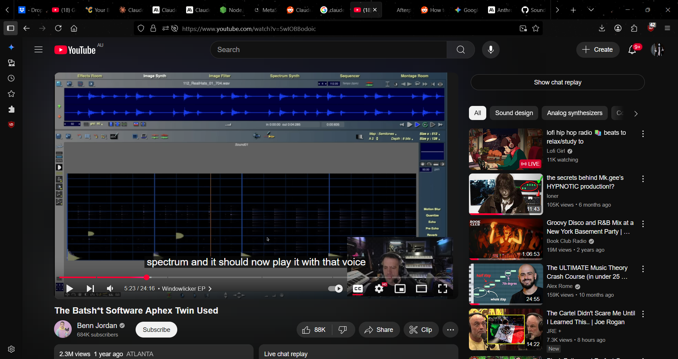

## Aphex Twin’s **Windowlicker** techniques

Aphex Twin’s experiments highlight MetaSynth’s potential. The Mixmag feature confirms that on the B‑side track **Formula**, James used MetaSynth to **embed an image at the end of the track**[[1]](https://mixmag.asia/feature/spectrogram-art-music-aphex-twin#:~:text=tweaking%2C%20particular%20tracks%20reveal%20images,placed%20there%20by%20the%20artist). At 5:27 the music turns into an unusual noise; when the sound is analysed on a spectrogram, a **grinning face** appears[[1]](https://mixmag.asia/feature/spectrogram-art-music-aphex-twin#:~:text=tweaking%2C%20particular%20tracks%20reveal%20images,placed%20there%20by%20the%20artist). On the A‑side *Windowlicker*, another hidden image appears: the last eight seconds contain a high‑pitched cry that produces a **spiral wave‑like image**[[2]](https://mixmag.asia/feature/spectrogram-art-music-aphex-twin#:~:text=On%20the%20same%20EP%20but,like%20swirl%20as%20Jarmo%20found). These Easter eggs were created by drawing images in the Image Synth, rendering them to audio and appending the resulting sound to the track. The ability to map pixel colour to stereo placement means the swirl literally defines the panning of the noise; brightness controls the amplitude of each partial. Because MetaSynth can load any picture as a sound or filter, James could import photographs or drawings and hear them as textures. The face in *Formula* is essentially an RGB image where red and green denote left and right channels, so the eyes and mouth swirl across the stereo field. The swirling finale of *Windowlicker* likely used a spiral drawn in the Image Synth; the spiral’s radius increases with pitch, producing the rising glissando heard on the record.

MetaSynth was not the only unusual tool in James’ arsenal. In interviews he has mentioned working with **Composer’s Desktop Project (CDP)**, a suite of command‑line sound‑transformation programs. CDP was designed for experimental composers in the 1980s and has since become free software.

## Composer Desktop Pro / Composer’s Desktop Project (CDP)

CDP is a **mature and wide‑ranging suite of sound‑manipulation programs** released under the GNU LGPL. The official site notes that it contains **hundreds of processes covering nearly every aspect of creative sound design** and emphasises transforming existing sounds in the tradition of musique concrète[[13]](https://www.composersdesktop.com/#:~:text=%3E%20,GNU%20Lesser%20General%20Public%20License). CDP 8 (released 2024) adds around **80 new processes**, including wavecycle distortion, multi‑channel tools, new PVOC (phase‑vocoder) functions and formant manipulation[[14]](https://www.composersdesktop.com/#:~:text=,improvements%2C%20extensions%20and%20bug%20fixes).

### Key features

The “CDP System: Key Features” page summarises the toolset:

* **Spectral processing:** functions such as *arpeggiate, average, blur, randomise, shuffle, freeze* and time‑expand reshape spectral content. Users can sustain spectral bands and slice the spectrum into bands to individually delay or pitch‑shift them[[15]](https://www.composersdesktop.com/cdpsystem.html#:~:text=,shift%20etc). These tools let composers smear or sharpen timbres, create spectral arpeggios and emphasise or suppress particular harmonics.
* **Transitions:** CDP can morph between sounds or create hybrids by imposing the characteristics of one sound on another[[16]](https://www.composersdesktop.com/cdpsystem.html#:~:text=,space%2C%20invert%20spectrum). It includes extensive support for automation so parameters can change over time.
* **Pitch processes:** sounds can be retuned by filtering or spectral manipulation, transposed and harmonised, or have their spectral ‘pitch’ extracted and altered. CDP allows pitch quantisation, inversion, randomisation and smoothing[[17]](https://www.composersdesktop.com/cdpsystem.html#:~:text=,quantize%2C%20exaggerate%2C%20invert%2C%20randomize%2C%20smooth).
* **Segment/extend:** tools for chopping sounds, repeating segments, dispersing fragments in time or space, creating polyrhythms and iterated delays[[18]](https://www.composersdesktop.com/cdpsystem.html#:~:text=,TEXTURE). CDP can zig‑zag through a sound or disperse zig‑zags spatially, apply multi‑tap delays and iterate with pitch shifts[[18]](https://www.composersdesktop.com/cdpsystem.html#:~:text=,TEXTURE).
* **Texture creation:** build textures from multiple repetitions of sound fragments placed on harmonic grids and combine several sources[[19]](https://www.composersdesktop.com/cdpsystem.html#:~:text=,CHANNEL).
* **Multi‑channel support:** many processes support multi‑channel output with spatial and channel effects, ambisonic support and sound diffusion[[20]](https://www.composersdesktop.com/cdpsystem.html#:~:text=%3E%20MULTI,shuffle%20or%20shift%20cycle%20groups).
* **Wavecycle distortion:** manipulate irregular wavecycles by repeating, reversing, shuffling or shifting cycle groups[[21]](https://www.composersdesktop.com/cdpsystem.html#:~:text=,irregular%20wavecycles%2C%20with%20possible%20distortion).
* **Vocal processing:** alter or preserve formants, manipulate vocal grains, repeat or delete segments, sustain or transpose vocal gestures and add harmonics or subharmonics[[22]](https://www.composersdesktop.com/cdpsystem.html#:~:text=,transpose%2C%20add%20harmonics%20and%20subharmonics).
* **Granular & creative editing:** granular reconstruction with multiple inputs and multi‑channel output; partition sounds into streams, extract wavetables, retime events and micro‑mix sounds to form complexes[[23]](https://www.composersdesktop.com/cdpsystem.html#:~:text=,ALGORITHMIC%20SCRIPTING).
* **Algorithmic scripting:** the Tabula Vigilans scripting language allows users to automate MIDI and CDP processes, controlling parameters over time or launching scripts that combine multiple tools[[24]](https://www.composersdesktop.com/cdpsystem.html#:~:text=,other%20scripts%20such%20as%20Csound).

### User interfaces

CDP’s programs are command‑line executables, but front‑end GUIs such as **Soundshaper** and **Sound Loom** simplify their use. Soundshaper is described as a free PC interface for CDP that **makes CDP quick and easy to use**[[25]](https://www.soundshaper.net/#:~:text=SOUNDSHAPER%E2%80%93CDP%20%C2%A0SOUND%20TRANSFORMATION). It fully supports CDP 8 and allows users to build **multi‑process patches** via an innovative grid[[26]](https://www.soundshaper.net/#:~:text=%3E%20,click%20recall%20of%20favourite%20patches). The site notes that CDP is not a real‑time system; processes write new files but can run faster than real‑time[[27]](https://www.soundshaper.net/#:~:text=,time.). CDP is noted to be **strong on segmentation, granular and textural techniques**, with many spectral processes that alter a sound’s time‑varying frequencies. Users can also process formants or pitch and combine characteristics in unusual ways[[28]](https://www.soundshaper.net/#:~:text=,in%20new%20and%20unusual%20ways). Later releases introduced multi‑channel processes, spectral splitting, rhythm transformation functions and a fast spectrally‑based convolver[[29]](https://www.soundshaper.net/#:~:text=,on%20segmentation%20and%20handling%20formants).

### Visualising CDP’s concept

Because CDP is primarily command‑line‑based, its “interface” is conceptual rather than visual. The generated illustration below symbolises CDP’s sound‑transformation philosophy: colourful spectral bands morphing and swirling over time. The swirling shapes evoke spectral morphing and granular segmentation.

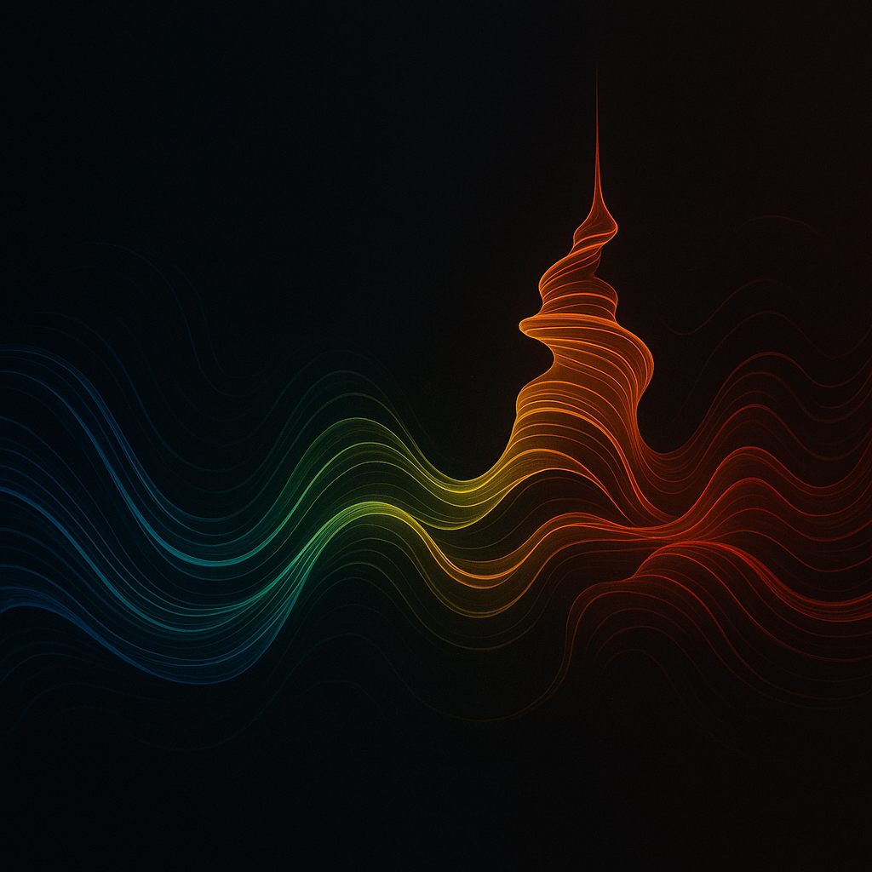

## What could be implemented in a modern VST?

A modern plug‑in could draw on MetaSynth’s and CDP’s most compelling features and adapt them to today’s real‑time workflows. Some ideas include:

### 1  Image‑based synthesiser and filter

* **Canvas for painting sound:** implement a 2D canvas where vertical position maps to pitch and horizontal position to time. Colour channels could control pan or route to multi‑output busses. The plug‑in would convert drawings into sequences of oscillators, using wavetables or spectral sources as instruments, and support user‑defined microtonal scales. Real‑time playback would allow performance by painting or loading images; offline rendering could allow high‑polyphony output. The ability to import any picture and hear it as sound would enable creative Easter eggs similar to the face in *Formula*[[5]](https://uisoftware.com/metasynth-manual/#:~:text=How%20MetaSynth%20Plays%20a%20Picture).
* **Image‑controlled filters:** adopt MetaSynth’s Image Filter concept by mapping pixel brightness to filter gain across frequency bands, enabling dynamic EQ and spectral sculpting. Users could draw filter envelopes and morph between multiple filter pictures.

### 2  Envelope‑driven effects suite

* Implement a suite of DSP effects—reverb, delay, granular shifters, convolution, spectral freeze—where **parameters are controlled by drawable envelopes**. The Effects Room’s envelope‑oriented control encourages movement and evolution[[9]](https://www.kvraudio.com/product/metasynth-by-u-and-i-software#:~:text=,all%20of%20MetaSynth%27s%20rooms%20together). The plug‑in could offer multi‑segment envelopes per parameter with tempo sync, randomisation and smoothing options. Real‑time automation would allow performers to draw effect curves while performing.

### 3  Spectral and granular processes inspired by CDP

* **Spectral morphing and hybridisation:** port CDP’s spectral morphing tools, allowing users to blend two samples by arpeggiating, blurring or shuffling their harmonic spectra[[15]](https://www.composersdesktop.com/cdpsystem.html#:~:text=,shift%20etc). Real‑time controls could interpolate between sources.
* **Time‑stretching and transitions:** integrate high‑quality phase‑vocoder stretching and morphing to glide between sounds; allow automation of morph parameters[[16]](https://www.composersdesktop.com/cdpsystem.html#:~:text=,space%2C%20invert%20spectrum).
* **Segmentation and texture builders:** include granular engines that chop sound into segments, repeat them at different rates, disperse them across the stereo field and build textures on harmonic grids[[30]](https://www.composersdesktop.com/cdpsystem.html#:~:text=,CHANNEL). Use multi‑channel routing for immersive outputs.
* **Wavecycle and formant tools:** incorporate wavecycle distortions and formant manipulation to create aggressive timbres or uncanny vocal effects[[31]](https://www.composersdesktop.com/cdpsystem.html#:~:text=,transpose%2C%20add%20harmonics%20and%20subharmonics).
* **Algorithmic control:** provide a scripting interface or modular environment (similar to Soundshaper’s patch grid) where users can chain processes, run parameter randomisation and integrate MIDI data[[32]](https://www.soundshaper.net/#:~:text=%3E%20,styles%2C%20including%20several%20dark%20themes). A mini‑language or node‑based editor would let advanced users build custom processing chains.

### 4  Integration and workflow

* **Modular architecture:** mimic MetaSynth’s room structure by offering modules for synthesis, filtering, sequencing, effects and mixing. Each module could run as part of a unified plug‑in or as separate mini‑effects. Users could drag audio or images between modules.
* **Real‑time spectrogram view:** display an animated spectrogram behind the canvas so users can see how their drawings affect the sound. Provide modes for linear or logarithmic frequency scales to reveal hidden images like Aphex Twin’s face.
* **Preset and filter libraries:** include collections of “sound pictures” and filter images, plus import/export functions for community sharing.
* **Multi‑channel support:** support surround or ambisonic outputs, enabling spectral spatialisation similar to CDP’s multi‑channel tools[[29]](https://www.soundshaper.net/#:~:text=,on%20segmentation%20and%20handling%20formants).

## Conclusion

MetaSynth and CDP are groundbreaking tools that treat **sound as an image or a malleable spectrum** rather than a fixed waveform. MetaSynth’s rooms allow users to paint sounds, draw filters, sequence images and process audio with dynamic envelopes, while CDP offers a deep library of spectral, granular and structural transformations. Aphex Twin’s *Windowlicker EP* demonstrates how these tools can embed pictures into music and create eerie spectral artwork[[1]](https://mixmag.asia/feature/spectrogram-art-music-aphex-twin#:~:text=tweaking%2C%20particular%20tracks%20reveal%20images,placed%20there%20by%20the%20artist)[[2]](https://mixmag.asia/feature/spectrogram-art-music-aphex-twin#:~:text=On%20the%20same%20EP%20but,like%20swirl%20as%20Jarmo%20found). A modern VST plug‑in inspired by these programs could bring image‑based synthesis and advanced spectral processing into real‑time production, opening new frontiers in sound design.

[[1]](https://mixmag.asia/feature/spectrogram-art-music-aphex-twin#:~:text=tweaking%2C%20particular%20tracks%20reveal%20images,placed%20there%20by%20the%20artist) [[2]](https://mixmag.asia/feature/spectrogram-art-music-aphex-twin#:~:text=On%20the%20same%20EP%20but,like%20swirl%20as%20Jarmo%20found) Spectogram art: A short history of musicians hiding visuals inside their tracks - Features - Mixmag Asia

<https://mixmag.asia/feature/spectrogram-art-music-aphex-twin>

[[3]](https://www.kvraudio.com/product/metasynth-by-u-and-i-software#:~:text=and%20fun%20to%20use,discover%20new%20sounds%20and%20textures) [[9]](https://www.kvraudio.com/product/metasynth-by-u-and-i-software#:~:text=,all%20of%20MetaSynth%27s%20rooms%20together) [[10]](https://www.kvraudio.com/product/metasynth-by-u-and-i-software) [[11]](https://www.kvraudio.com/product/metasynth-by-u-and-i-software#:~:text=,and%20recording%20room%20with%20a) [[12]](https://www.kvraudio.com/product/metasynth-by-u-and-i-software#:~:text=,Expansion%20packs%20are%20also%20available) MetaSynth by U&I Software - Sound Design Composition Sequencing Application

<https://www.kvraudio.com/product/metasynth-by-u-and-i-software>

[[4]](https://uisoftware.com/metasynth-manual/#:~:text=The%20Image%20Synth%20Room%20provides,harmonic%20spectra) [[5]](https://uisoftware.com/metasynth-manual/#:~:text=How%20MetaSynth%20Plays%20a%20Picture) [[6]](https://uisoftware.com/metasynth-manual/#:~:text=The%20Image%20Synth%20Room%20provides,harmonic%20spectra) [[7]](https://uisoftware.com/metasynth-manual/#:~:text=The%20Image%20Synth%20makes%20use,libraries%20are%20collections%20of%20pictures) [[8]](https://uisoftware.com/metasynth-manual/#:~:text=) MetaSynth Manual - U&I Software, LLC

<https://uisoftware.com/metasynth-manual/>

[[13]](https://www.composersdesktop.com/#:~:text=%3E%20,GNU%20Lesser%20General%20Public%20License) [[14]](https://www.composersdesktop.com/#:~:text=,improvements%2C%20extensions%20and%20bug%20fixes) CDP Home

<https://www.composersdesktop.com/>

[[15]](https://www.composersdesktop.com/cdpsystem.html#:~:text=,shift%20etc) [[16]](https://www.composersdesktop.com/cdpsystem.html#:~:text=,space%2C%20invert%20spectrum) [[17]](https://www.composersdesktop.com/cdpsystem.html#:~:text=,quantize%2C%20exaggerate%2C%20invert%2C%20randomize%2C%20smooth) [[18]](https://www.composersdesktop.com/cdpsystem.html#:~:text=,TEXTURE) [[19]](https://www.composersdesktop.com/cdpsystem.html#:~:text=,CHANNEL) [[20]](https://www.composersdesktop.com/cdpsystem.html#:~:text=%3E%20MULTI,shuffle%20or%20shift%20cycle%20groups) [[21]](https://www.composersdesktop.com/cdpsystem.html#:~:text=,irregular%20wavecycles%2C%20with%20possible%20distortion) [[22]](https://www.composersdesktop.com/cdpsystem.html#:~:text=,transpose%2C%20add%20harmonics%20and%20subharmonics) [[23]](https://www.composersdesktop.com/cdpsystem.html#:~:text=,ALGORITHMIC%20SCRIPTING) [[24]](https://www.composersdesktop.com/cdpsystem.html#:~:text=,other%20scripts%20such%20as%20Csound) [[30]](https://www.composersdesktop.com/cdpsystem.html#:~:text=,CHANNEL) [[31]](https://www.composersdesktop.com/cdpsystem.html#:~:text=,transpose%2C%20add%20harmonics%20and%20subharmonics) CDP System

<https://www.composersdesktop.com/cdpsystem.html>

[[25]](https://www.soundshaper.net/#:~:text=SOUNDSHAPER%E2%80%93CDP%20%C2%A0SOUND%20TRANSFORMATION) [[26]](https://www.soundshaper.net/#:~:text=%3E%20,click%20recall%20of%20favourite%20patches) [[27]](https://www.soundshaper.net/#:~:text=,time.) [[28]](https://www.soundshaper.net/#:~:text=,in%20new%20and%20unusual%20ways) [[29]](https://www.soundshaper.net/#:~:text=,on%20segmentation%20and%20handling%20formants) [[32]](https://www.soundshaper.net/#:~:text=%3E%20,styles%2C%20including%20several%20dark%20themes) Soundshaper Homepage

<https://www.soundshaper.net/>